**Week 10**

**Aim**

Write a program to demonstrate application on Ajax, Node.js and JSON.

**DESCRIPTION**

AJAX is Asynchronous JavaScript And XML.It is not a programming language. AJAX just uses a combination of:

* A browser built-in XMLHttpRequest object (to request data from a web server)
* JavaScript and HTML DOM (to display or use the data)

AJAX allows web pages to be updated asynchronously by exchanging data with a web server behind the scenes. This means that it is possible to update parts of a web page, without reloading the whole page. AJAX is a web browser technology independent of web server software.

Ajax uses XHTML for content, CSS for presentation, along with Document Object Model and JavaScript for dynamic content display.

With AJAX, when you hit submit, JavaScript will make a request to the server, interpret the results, and update the current screen. In the purest sense, the user would never know that anything was even transmitted to the server.

XML is commonly used as the format for receiving server data, although any format, including plain text, can be used.

**NODE JS**

Node.js (Node) is an open source development platform for executing JavaScript code server-side. Node is useful for developing applications that require a persistent connection from the browser to the server and is often used for real-time applications such as chat, news feeds and web push notifications.

Node.js is intended to run on a dedicated HTTP server and to employ a single thread with one process at a time. Node.js applications are event-based and run asynchronously. Code built on the Node platform does not follow the traditional model of receive, process, send, wait, receive. Instead, Node processes incoming requests in a constant event stack and sends small requests one after the other without waiting for responses

**PROGRAM(S)**

**AJAX AND JSON**

PROGRAMS

Index.html

<!doctype html>

<html lang="en">

<head>

<title>Ajax + JSON </title>

</head>

<body>

<h1>Ajax tutorial</h1>

<button type="button" id="getData">Get Data</button>

<button type="button" id="PostData" class="btn btn-secondary">Post Data</button>

<p> Check output on console</p>

<script src="ex5.js"></script>

</body>

</html>

**Index.js**

let fetchBtn = document.getElementById('getData');

fetchBtn.addEventListener('click', pullData)

function pullData() {

const xhr1 = new XMLHttpRequest();

xhr1.open('GET', 'https://dummy.restapiexample.com/api/v1/employees',true);

xhr1.onload = function () {

if(this.status === 200){

console.log(this.responseText)

}

else{

console.log("Some error occured")

}

}

xhr1.send();

console.log("We are done!");

}

let popBtn = document.getElementById('PostData');

popBtn.addEventListener('click', pushData);

function pushData() {

const xhr = new XMLHttpRequest();

xhr.open('POST', 'http://dummy.restapiexample.com/api/v1/create', true);

xhr.getResponseHeader('Content-type', 'application/json');

xhr.onload = function () {

if(this.status === 200){

console.log(this.responseText)

}

else{

console.log("Some error occured")

}

}

params = '{"name":"hello123","salary":"1245463","age":"21"}';

xhr.send(params);

}

**NODE JS**

EXPORT_SERVICE_EXAMPLE.JS

var h1= require('./export_service.js')

var sum=h1.add_exp(2,3)

console.log("Sum is "+sum)

var diff=h1.sub_exp(2,3)

console.log("Diff is "+diff)

var prod=h1.mul_exp(2,3)

console.log("Prod is "+prod)

**EXPORT_SERVICE:**

function add(a,b){

return a+b

}

function sub(a,b){

return a-b

}

function bank_credentials(){

console.log("Hello")

}

exports.mul_exp=function mul(a,b){

bank_credentials()

return a*b

}

module.exports.add_exp=add

exports.sub_exp=sub

**Node.js**

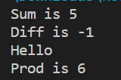

**Ajax**

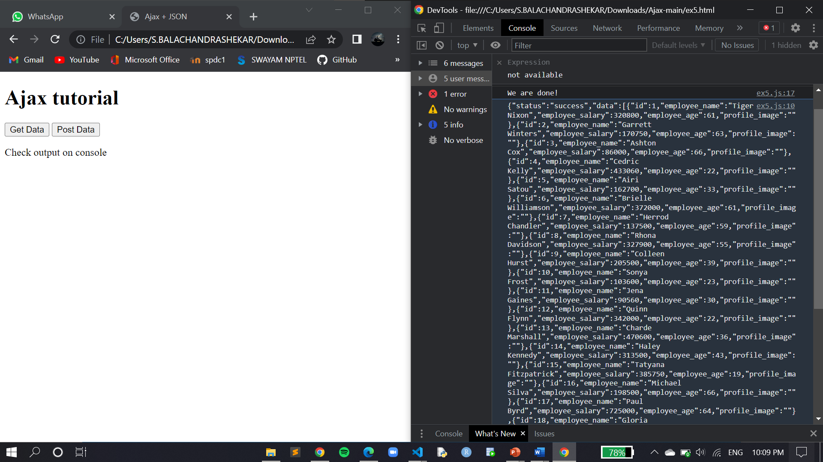

**CONCLUSION:**

Hence the required output for ajax and node.js has been obtained.